Project Design Phase-II
Data Flow Diagram & User Stories

Date | 25 October 2026
Team ID | Individual
Project Name | EV Market Analysis
Maximum Marks | 4 Marks

Data Flow Diagrams:
A Data Flow Diagram (DFD) is a traditional visual representation of the information flows within a system. A neat and clear DFD can depict the right amount of the system requirement graphically. It shows how data enters and leaves the system, what changes the information, and where data is stored.
DFD Symbol Legend
Symbol | Name | Description
Oval / Rounded  shape | External Entity | A person, organization, or system outside the project that sends or receives data (e.g., Customer, Payment Gateway).
Rectangle with  numbered header | Process | An activity that transforms incoming data into outgoing data (e.g., Validate Request, Process Order).
Rectangle (solid fill, no number) | Data Store | A place where data is held for later use (e.g., Customer Database, Inventory).
Labeled arrow | Data Flow | The movement of data between entities, processes, and data stores, labeled with what data is being passed.

Example: DFD Level 0 (Industry Standard)

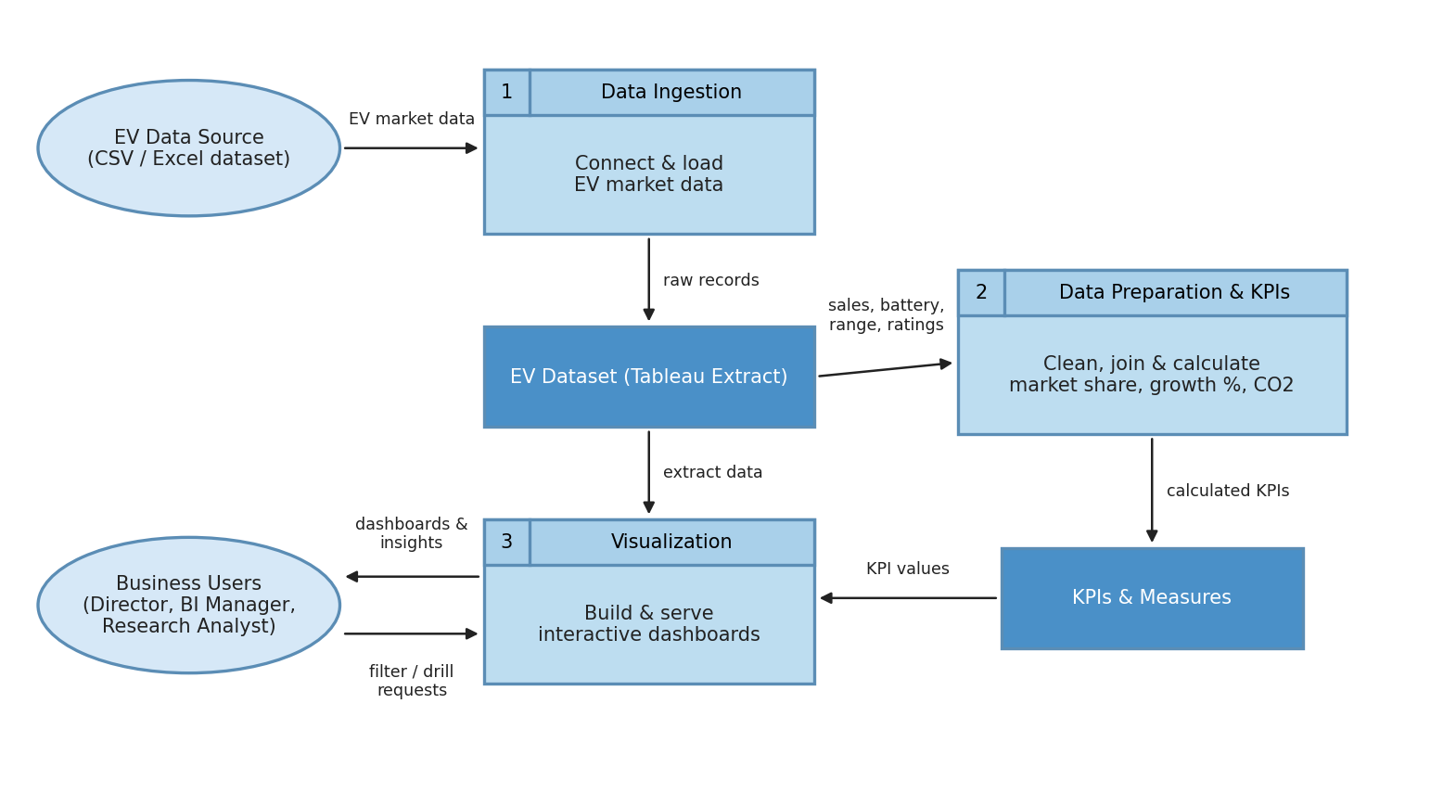

User Stories
Use the below template to list all the user stories for the product.
User Type | Functional Requirement (Epic) | User Story Number | User Story / Task | Acceptance criteria | Priority | Release
Market Strategy Director | Sales Performance Analysis | USN-1 | As a Market Strategy Director, I can view total sales and annual sales by vehicle category so that I can see which categories contribute most to annual sales. | Annual Sales by Category chart ranks all categories and Total Sales KPI is displayed | High | Sprint-1
 |  | USN-2 | As a Market Strategy Director, I can see the top 10 manufacturers by sales so that I can identify the leading manufacturers. | Top 10 Manufacturers By Sales chart shows ranked bars with sales units | High | Sprint-1
 | Customer Satisfaction | USN-3 | As a Market Strategy Director, I can compare average customer rating across vehicle categories so that I can evaluate satisfaction by product segment. | Customer Rating by Category chart shows the average rating for every category | Medium | Sprint-1
 | Growth & Technology Trends | USN-4 | As a Market Strategy Director, I can view the top 5 sales growth by year so that I can identify high-growth market segments. | Top 5 Sales Growth by Year line chart shows % difference in sales for each model year | High | Sprint-2
 |  | USN-5 | As a Market Strategy Director, I can view battery technology adoption and average range by vehicle category so that I can plan the product portfolio. | Battery Technology Adoption treemap and Average Range by Vehicle Category are displayed | High | Sprint-1
Automotive BI Manager | Manufacturer Competitive Analysis | USN-6 | As a BI Manager, I can see the market share of the top 10 manufacturers so that I can identify competitive advantages. | Manufacturer Market Share Top 10 chart shows share % for each manufacturer | High | Sprint-2
 |  | USN-7 | As a BI Manager, I can see sales by manufacturing country on a map so that I can understand geographical production trends. | Map shows total sales by country with labels and tooltips | Medium | Sprint-2
 |  | USN-8 | As a BI Manager, I can compare rating vs sales for each manufacturer so that I can position products and recommend clients' market entry. | Scatter plot shows total sales against average rating with average reference lines | Medium | Sprint-2
Sustainable Mobility Research Analyst | Battery & Range Research | USN-9 | As a Research Analyst, I can compare battery technologies (LFP, NMC, NCA, Sodium-Ion, Solid-State) and their range over model years so that I can find technology trends. | Range Over Time heatmap and Battery Technology Distribution pie chart are displayed | High | Sprint-2
 |  | USN-10 | As a Research Analyst, I can view the annual sales trend and CO2 emissions prevented so that I can assess the impact of EV adoption on sustainability. | Annual Sales Trend line chart and CO2 Emission Prevented KPI are displayed | Medium | Sprint-3
All users | Interaction & Navigation | USN-11 | As a user, I can filter, highlight and navigate between the two dashboards so that I can explore the data for my own question. | Filters and dashboard actions update all related charts correctly | Medium | Sprint-3
Administrator (Data owner) | Data Refresh & Publishing | USN-12 | As an Administrator, I can refresh the data source and republish the dashboards so that users always see updated figures. | Refreshed extract updates the KPIs and the published dashboard opens without errors | Low | Sprint-3

